CAPSTONE PROJECT  
Cloud Devops Final Project – Docker and Kubernates Deployment

The document has three sections:

**NEW SECTION: BLUE / GREEN Deployment into Kubernetes cluster and expose the cluster via a service**

**NEW SECTION: BLUE / GREEN Deployment into Kubernetes cluster and expose the cluster via a service**

**Run Jenkins pipeline**

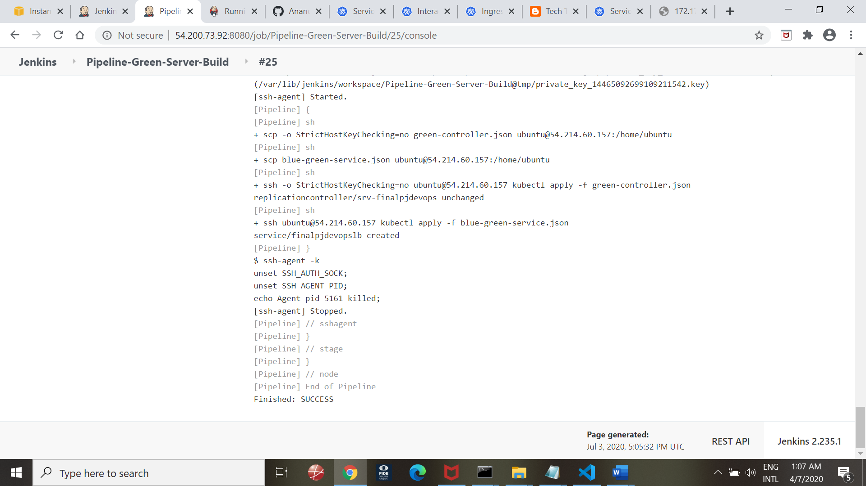

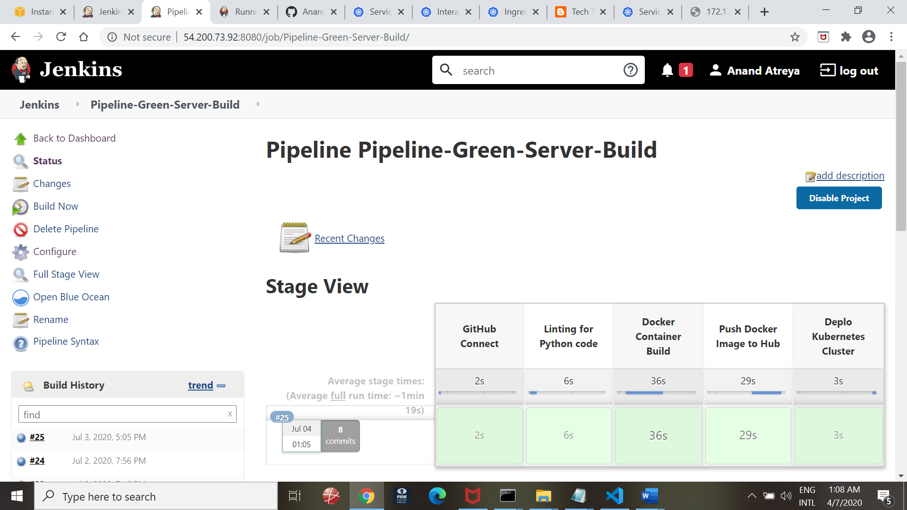

**View from BlueOcean:**

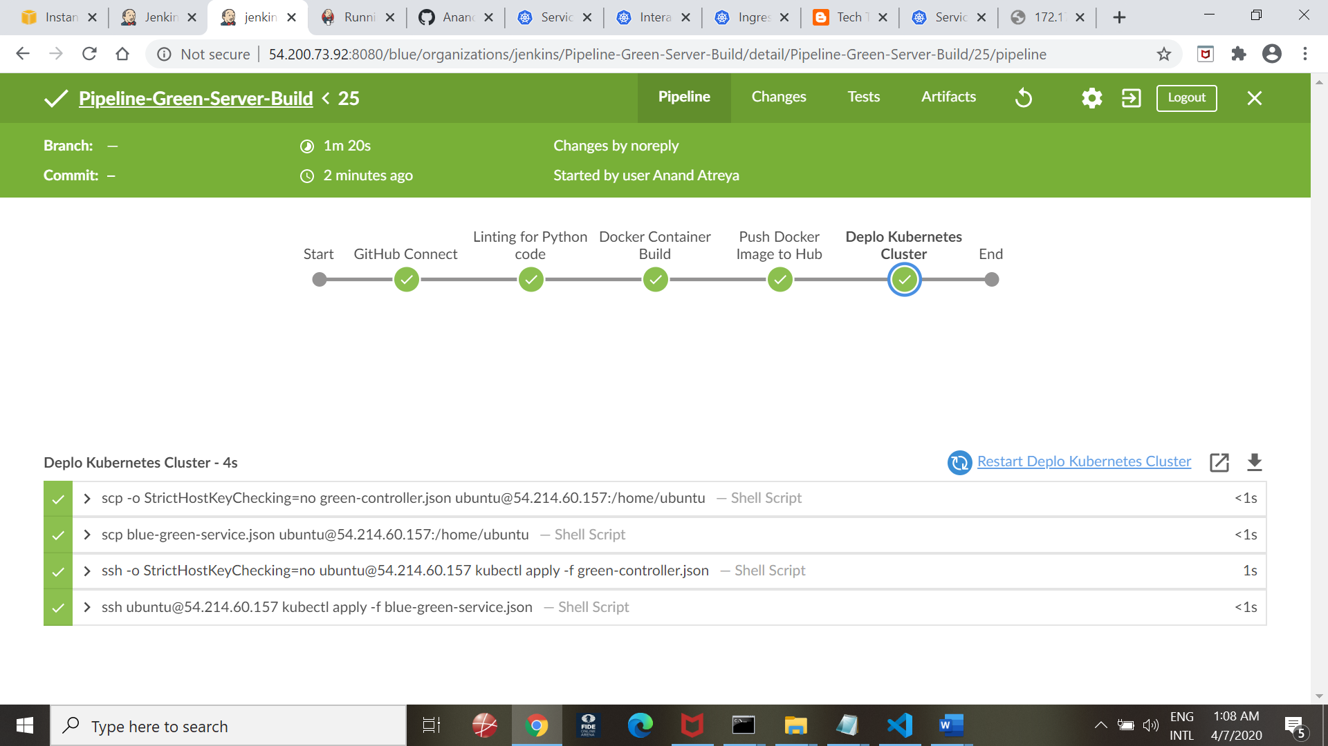

**Kubectl describe services output**

**Kubectl get pods**

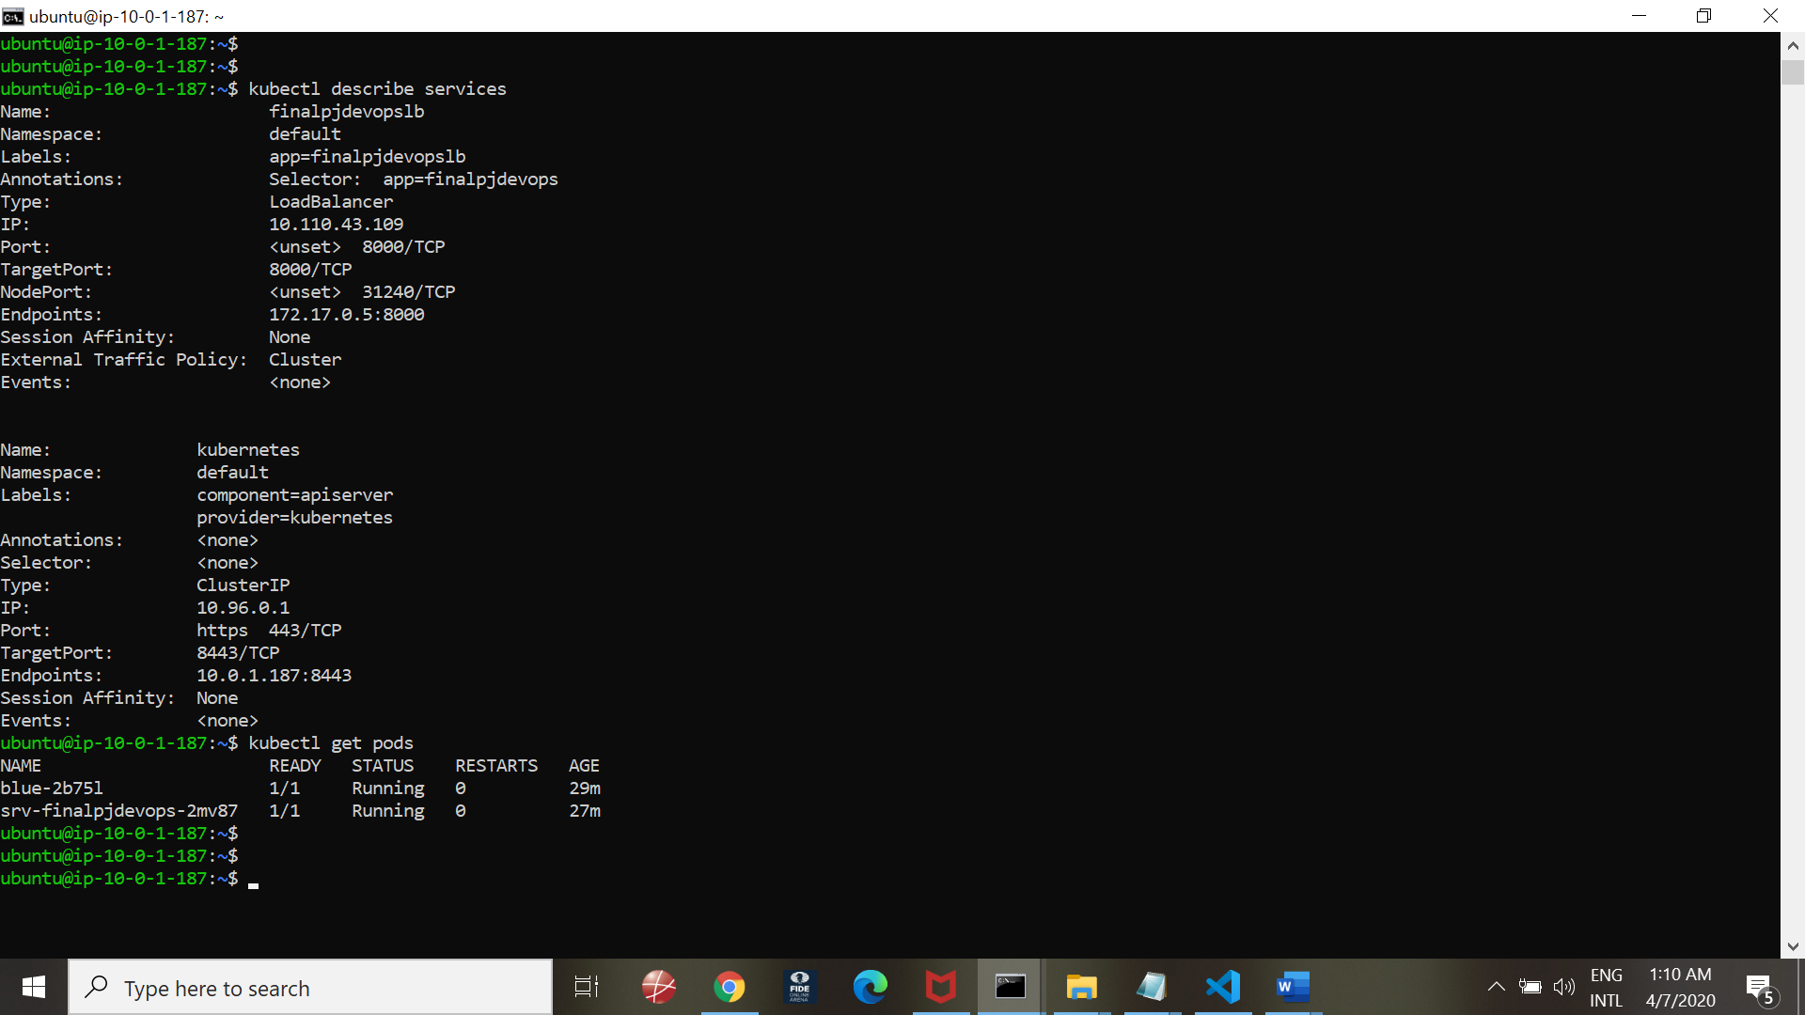

**Tests:**

**Curl command on the endpoint:**

**curl** [**http://172.17.0.5:8000**](http://172.17.0.5:8000)

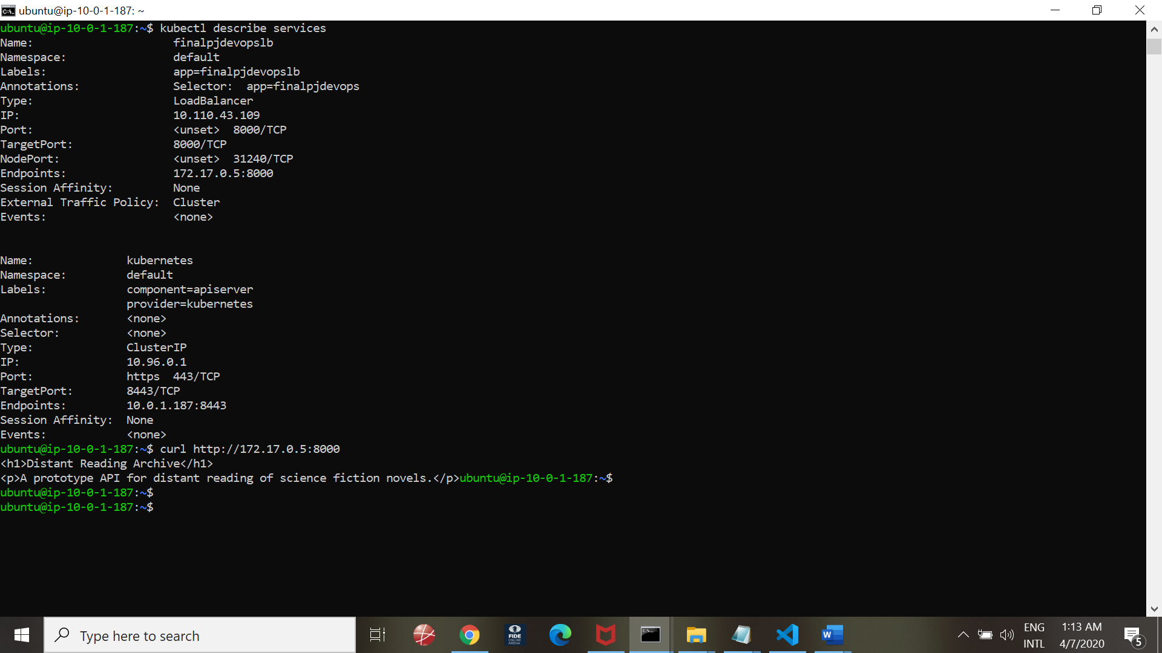

**Minikube output:**

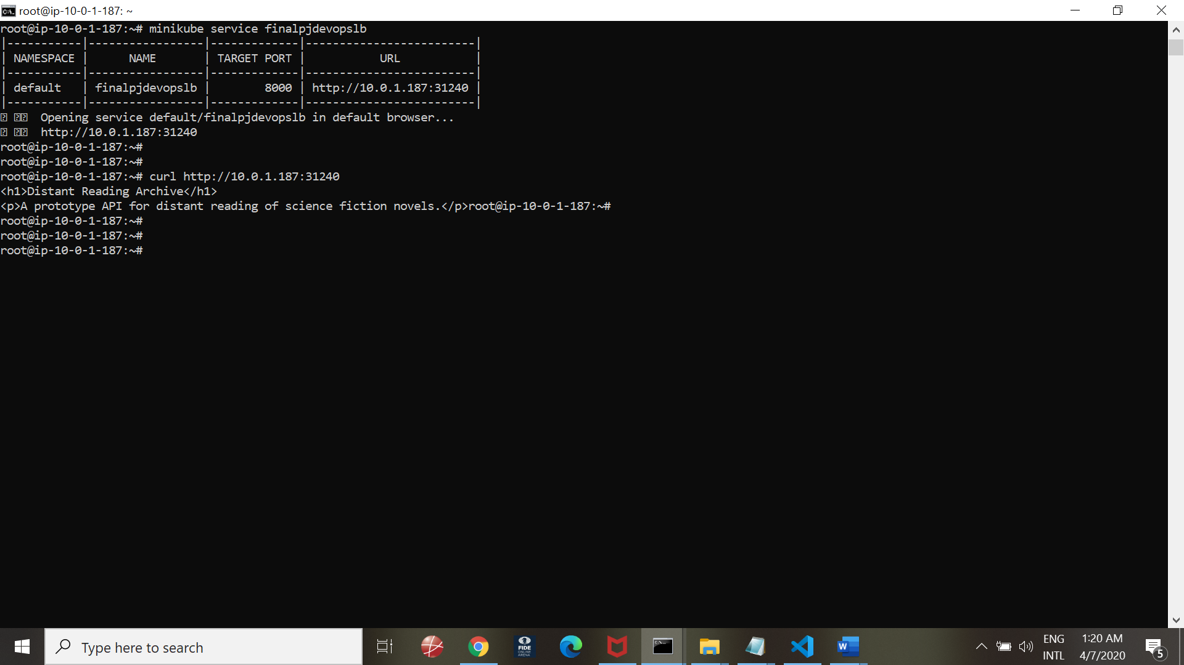

**Blue Deployment:**

**Ran the Jenkins Pipeline:**

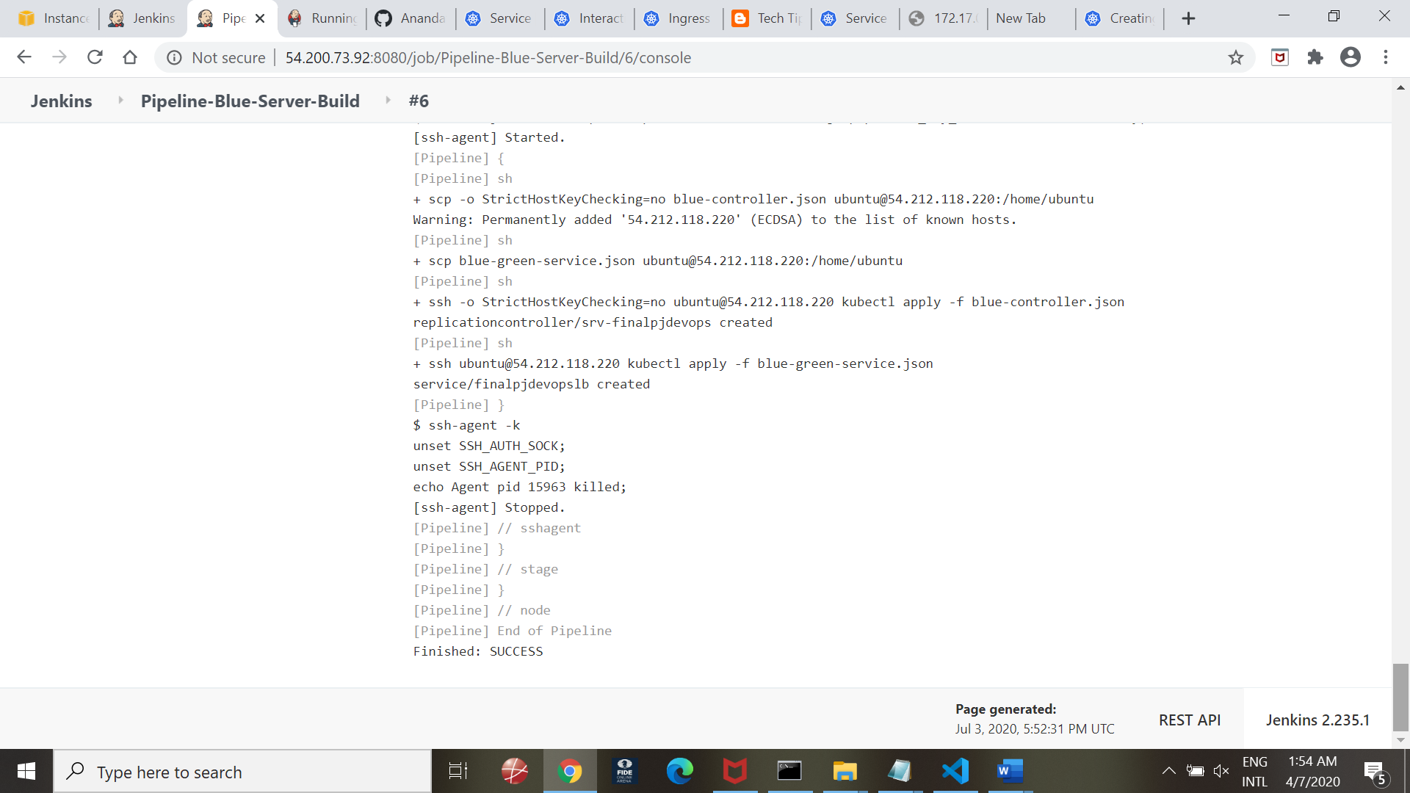

**BlueOcean output:**

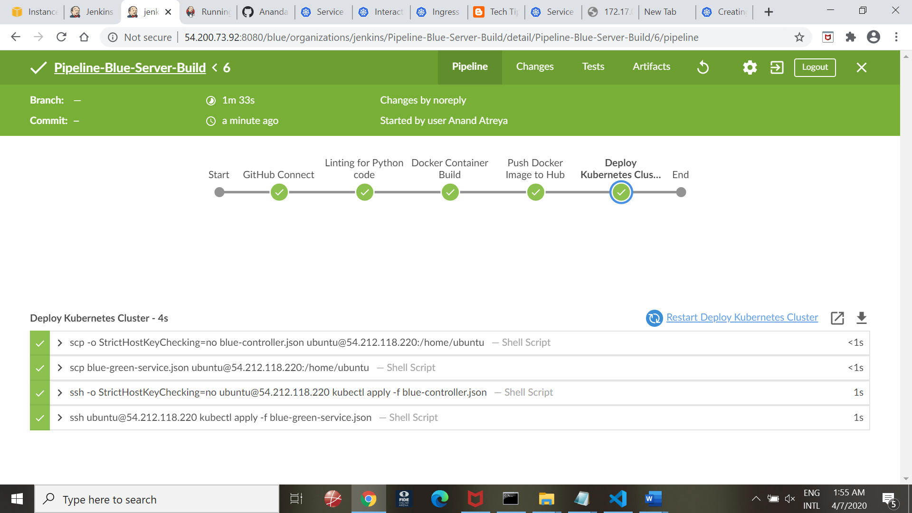

**Verification:**

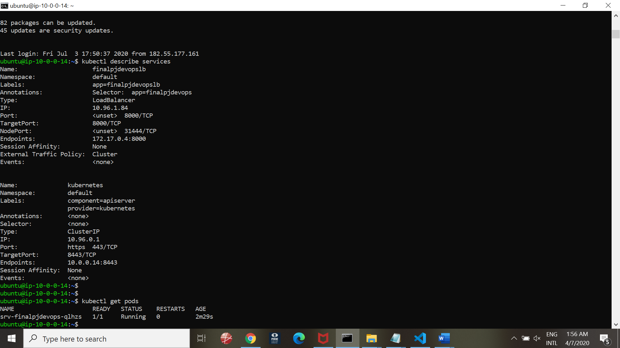

**Basic tests using CURL:**

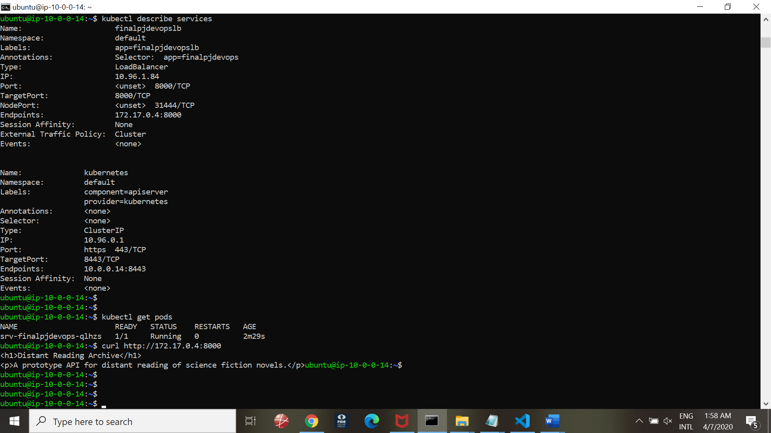

**Minikube service output:**

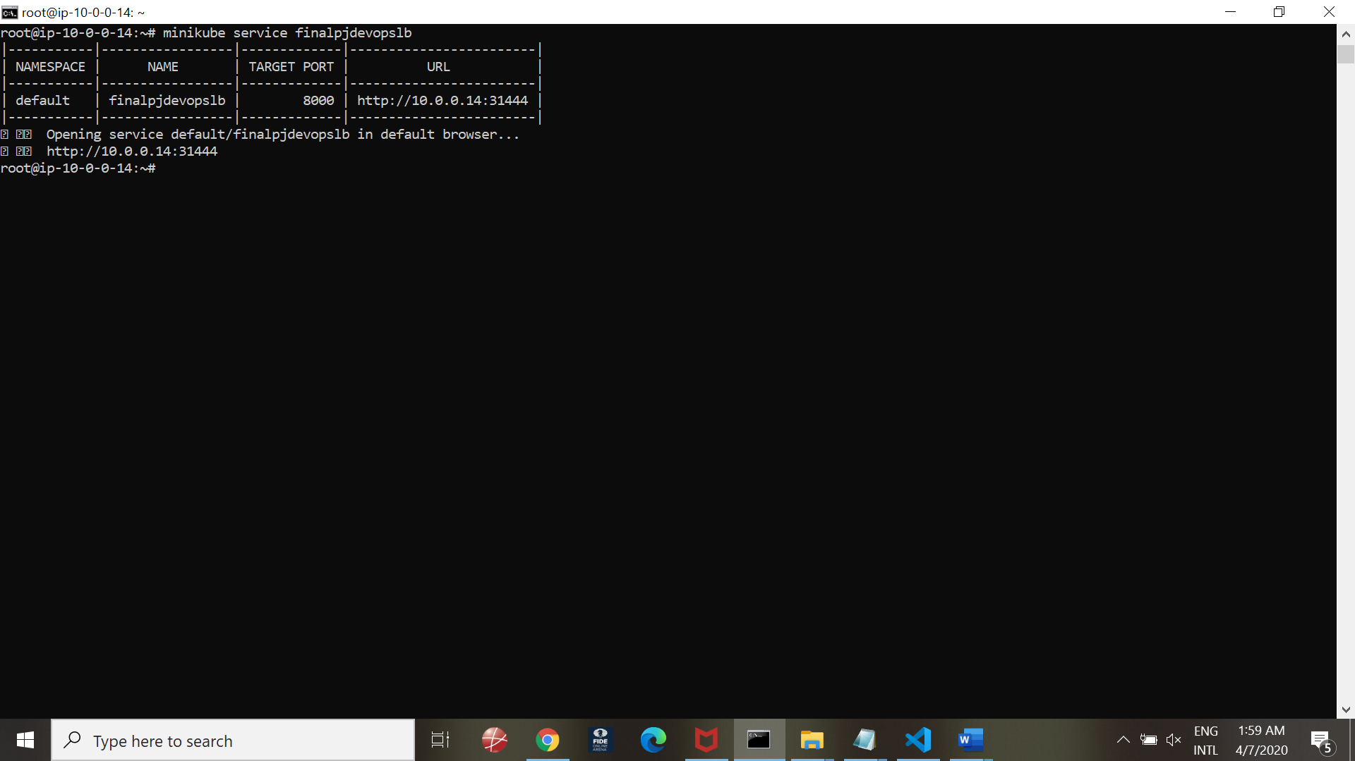

**Testing for URL access:** 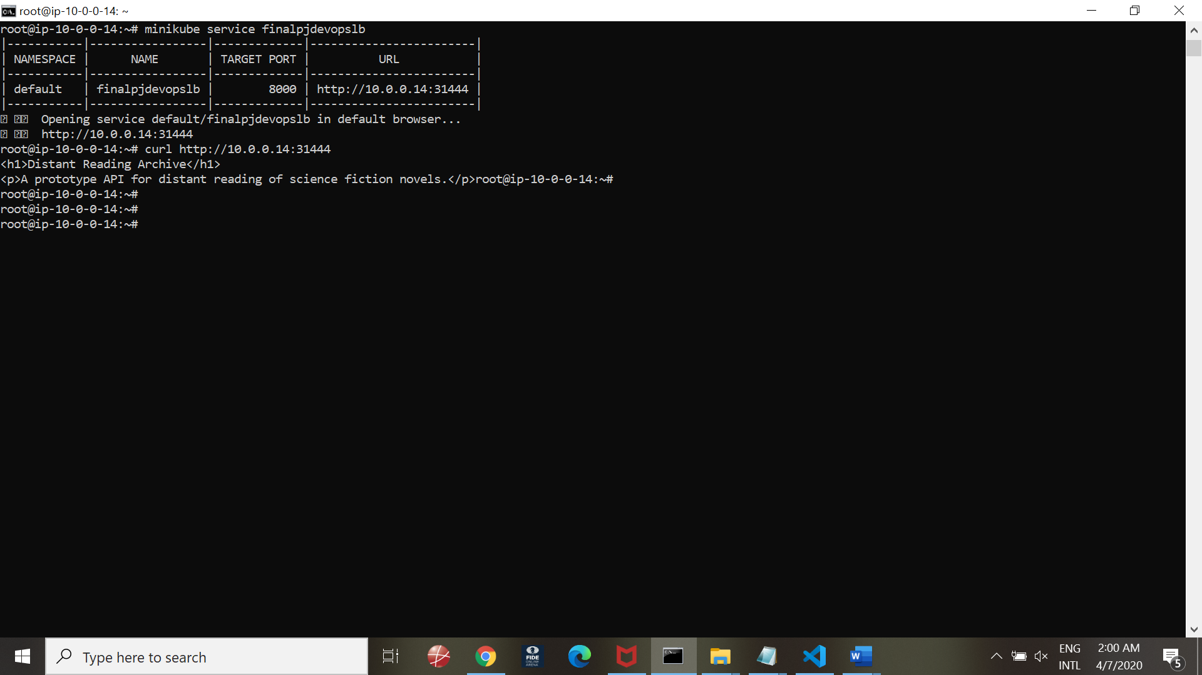

END--